“Investing in our nation’s future, the first 100 days of the new government” – Campaign Update

**Purpose**

For discussion and direction.

**Summary**

To look at the achievements and activity of the LGA’s campaign, “Investing in our nation’s future, the first 100 days of the new government”.

|  |
| --- |
| **Recommendation**  That the LGA Executive notes the outcomes of our campaign, “investing in our nation’s future, the first 100 days of the new government.”  **Action**  Officers to progress in line with Members’ direction. |

|  |  |
| --- | --- |
| **Contact officer:** | Laurence Meehan |
| **Position:** | Head of Campaigns and External Communications |
| **Phone no:** | 0207 664 3127 |
| **Email:** | [laurence.meehan@local.gov.uk](mailto:laurence.meehan@local.gov.uk) |

“Investing in our nation’s future, the first 100 days of the new government” – Campaign Update

**Introduction**

1. This paper summarises the activity and outcomes of the LGA’s general election facing campaign “Investing in our nation’s future, the first 100 days of the new government” (“100 days”).

**Background**

1. We launched “100 days” at our annual conference in July 2014. The campaign was a direct follow up to our “Rewiring Public Services” and the “Future Funding Outlook” campaigns which had been launched in the two previous years.
2. Throughout 2013 and 2014 “Rewiring Public Services” successfully positioned local government, and the LGA, as the progressive part of the public sector willing to look at radical ideas to address the significant funding and demand issues faced by the country. In discussions with politicians of all sides and stakeholders, the campaign was warmly welcomed, but with feedback that it’s more theoretical approach should be followed up by more practical policy suggestions supported by full costings.
3. The result was “100 days” which aimed to build on the success of “Rewiring Public Services” by setting out the concrete steps that the government taking power in May 2015 must take to address demand and funding in a wide range of areas such as housing, social care and skills.
4. The campaign was launched in July 2014, with the following objectives as agreed by the LGA Leadership Board:
   1. To continue to influence the manifesto formulation process ahead of the May 2015 General Election.
   2. To give the new government a clear set of actions to help transform public services in a way that will address the current funding gap and give local authorities the powers to deliver better outcomes for residents.
   3. To ensure that local government is involved in the general election debates in the months leading up to May 2015.
   4. To ensure that the LGA’s lobbying strategy has momentum beyond May 2015.
5. The campaign focused on number of key areas:
   1. Housing (affordability, supply and rental sector).
   2. Skills/employment (including unemployment).
   3. Infrastructure (including roads).
   4. Fiscal devolution (including debates on Scottish independence).
   5. Health and Social Care (including aging population, social care and public health).
   6. Public service transformation (including community budgets and integration).
   7. Children/Education (including school places, free schools and academies, inspection and our “Ambition for Children”).

**Manifestos and the new government**

1. In the lead up to the 2015 General Election the LGA worked to strategically influence the manifesto process using all possible channels into the manifesto formulation process. This work is detailed further in this paper but included:
   1. Direct conversations with Party policy teams through LGA lead members and LGA Group offices.
   2. Contributions through various Party policy boards, working groups (this includes work such as the Labour Local Government Innovation Taskforce), discussions and policy motions alongside significant input into the final manifestos.

* 1. Profile raising in Parliament, ensuring that key players in the manifesto process were aware of our “100 days” “Asks”.
  2. Working with stakeholders to build wide coalitions around specific policies.
  3. A significant meeting programme for the Chairman, Group Leaders and officers.
  4. Strong media profile for our “asks”.

1. As a result of this work the following manifesto commitments were achieved:

| “100 days” call | Manifesto commitment |
| --- | --- |
| Build half a million more homes so people can find a place they can afford. | A commitment from Conservative, Labour, Liberal Democrats, UKIP and Greens to build more homes. |
| More devolution of power to elected councillors to enable them to rewire public services. | A commitment from five of the political parties (Conservative, Labour, Liberal Democrats, UKIP and Greens) to devolve a range of economic powers to local areas.  A commitment from the Conservative Party to review how central government can further reduce ring-fencing and Whitehall burdens to give councils more flexibility to support local services. |
| Fully integrate the funding for the commissioning of adult social care and health as a step towards the single point of commissioning. | A commitment from the Conservatives, Labour and Liberal Democrats to integrate health and social care funding. |
| Let councils set rates and discounts for council tax and business rates so they can better respond to local circumstances.  Let councils retain 100 per cent of business rates growth without a corresponding cut in revenue support grant, further incentivising councils to grow local economies. | A commitment from the Conservatives, Labour and Liberal Democrats to reform business rates. |
| Financial settlements tied to the lifetime of Parliament for all of the public sector. | A commitment from the Labour Party to create multi-year budgets so that local authorities can plan ahead. |
| Scrap the Right to Buy scheme's complex arrangements for councils and ensure the discount offered is in line with the local housing market and stimulates sales, and that the receipts from sales are retained directly by the council to reinvest in replacement housing. | A commitment from the Liberal Democrats and UKIP either devolve full control of Right to Buy or reinvest 100 per cent of Right to Buy sales back into community housing. |
| Allow councils to retain any savings to the housing benefit bill locally for reinvestment in housing. | A commitment from Labour and the Greens to give councils more freedom over housing benefits and rent reductions. |

1. Following the General Election we have worked closely with the new Government to ensure their manifesto commitments that supported our 100 days “asks” are delivered. These include:
   1. A Cities and Local Government Devolution Bill to create enabling powers which deliver on the Government’s manifesto commitments on devolution.
   2. Legislation in the form of the Psychoactive Substances Bill to give councils the powers to make licensing decisions on legal highs.
   3. A further commitment of £6 million to the One Public Estate Programme.
   4. A commitment to continue to integrate the health and social care system through the Better Care Fund.
   5. A commitment to a wide-ranging business rates review and including allowing councils in Cambridgeshire, Greater Manchester and Cheshire East to retain 100 per cent of growth in business rates.

**Stakeholders**

1. As directed by the Leadership Board, utilising stakeholders was essential to the campaign in order to increase the reach, support and evidence base for of local government’s pre-election “asks” of a new government. As a result we targeted a number of high profile organisations such as CBI, NHS Confederation and the Joseph Rowntree Foundation and to date to date; thirty nine stakeholders have supported the campaign.

**“Thoughts on”**

1. As part of our work with stakeholders we asked organisations to, by publishing a blog on our campaign website, provide their ‘thoughts on’ what they would like a new government to action in its first 100 days. This process enabled these high profile organisations to share their thoughts on public services whilst sharing our campaign with their members. As a result we saw a significant lift in web traffic from these stakeholders to our own campaign site.

|  |  |
| --- | --- |
| **Stakeholders we worked with** | **Twitter followers** |
| Action for Children | 96,600 |
| Age UK | 78,400 |
| Alcohol Concern | 8,103 |
| Asphalt Industry | 138 |
| CBI | 34,600 |
| Centre Forum | 4,389 |
| Centre Point | 22,500 |
| CILT | 5,219 |
| CLGF | 702 |
| Cycle to Work Alliance | 184 |
| Electrical Safety First | 7,834 |
| FMB | 12,700 |
| Guide Dogs | 52,100 |
| Home Builders Federation | 14,100 |
| JRF | 119,000 |
| Living Streets | 11,400 |
| Localis | 1,909 |
| London Chambers of Commerce | 8,118 |
| NatCen | 9,734 |
| NCVO | 44,000 |
| NFB | 4,459 |
| National Obesity Forum | N/a |
| National Trust | 360,000 |
| Prospects | 32,000 |
| RAC Foundation | 3,378 |
| Ramblers | 20,700 |
| Reform | 7,918 |
| RSPCA | 200,000 |
| RTPI | 9,567 |
| Scope | 73,300 |
| St Mungo’s Broadway | 15,900 |
| The Children’s Society | 44,700 |
| The Kennel Club | 42,700 |
| The Kings Fund | 75,900 |
| Trading Standards Institute | 3,907 |
| UK Health Forum | 2,740 |
| Universities UK | 49,400 |
| Water UK | 4,956 |
| Woodland Trust | 93,000 |
| **Potential reach** | **1,576,255** |

**Publications**

1. To date, the main “100 days” publication has been download 9,303 times with an additional 4,000 hard copies distributed at conference, party conferences and events throughout the year.
2. Eight further “100 days” publications were also produced as part of the campaign, all of which have been well received:

|  |  |  |
| --- | --- | --- |
| Publication | Downloads | Printed copies |
| Tackling the causes and effects of alcohol misuse | 9,017 | 200 |
| Tackling tobacco and nicotine dependency | 1,180 | 200 |
| Realising talent: a new framework for devolved employment and skills | 2,305 | 100 |
| Making sure every child has a place at a good local school | 896 | 100 |
| Better roads for England | 2,081 | N/a |
| Council tax support: the story continues | 4,140 | 150 |
| Tackling the causes and effects of obesity | 10,274 | 200 |
| The fire and rescue service: making our nation safer | 3,851 | 400 |
| Total | 33,744 | 1,350 |

**Parliamentary profile**

1. 2014/15 was the last parliamentary session before Parliament dissolved for the General Election. We worked closely with our Vice Presidents and network of parliamentary supporters to ensure the LGA’s 100 days campaign benefited from a high profile. The LGA was mentioned 1429 times in Parliament in the 2014/15 session, highlighting the significant coverage secured for our 100 days recommendations.

*Briefings*

1. As a part of this work, we prepared 60 formal written briefings, nearly all of which promoted our 100 days recommendations. The chart below set out the policy areas in 100 days covered by our briefings:

*Parliamentary inquiries*

1. Alongside our briefings, we provided evidence (either written or oral) to 22 parliamentary inquiries. Our former Chair Cllr Sparks gave evidence to the Political and Constitutional Reform Committee and set out our 100 days policies on devolution. Our former Chief Executive Carolyn Downs gave evidence to the Health Committee and the Public Account Committee, at which she discussed the technical policy detail behind our recommendations on health and social care integration.
2. We also worked with a number of All-Party Parliamentary Groups to promote our 100 days campaign. For example, we provided secretarial support to the All Party Parliamentary Group on Reform, Decentralisation and Devolution in the United Kingdom and worked with the Group on a legacy report, *A Parliament for Reform 2015-2020*, which outlined the constitutional questions that needed to be answered in the new Parliament, including the question of further devolution in England.
3. The graph below sets out the policy subjects covered by our engagement with Select Committee inquiries:

*Parliamentary contact programme*

1. In addition, as part of our contact programme with parliamentarians; held formal technical briefings for parliamentarians on our 100 days recommendations; tabled a cross-party parliamentary motion on the need for fair funding for local government signed by 30 MPs from across the political spectrum; and worked closely with select committees and All-Party Parliamentary Groups. All of this activity was designed to ensure that the 100 days campaign was shaping and influencing parliamentary debate.
2. In reputational polling commissioned on behalf of the LGA, more than a third (35 per cent) of MPs said they were aware of *‘Investing in Our Nation’s Future: the First 100 days of the Next Government’*. Of those who supported the campaign, reasons for supporting it included ‘a belief our policies would be a key driver of growth’ and/or ‘a concern that local government is currently under-funded’.

*Legislation*

1. We also lobbied on a number of key pieces of primary legislation in order to secure positive changes that helped support our 100 days campaign recommendations. A key highlight was the Infrastructure Act through which we secured a new statutory provision ensuring that fracking cannot take place unless companies engaged in shale gas extraction provide financial or other benefit for the local area.

**Party conferences**

1. Following its launch at our 2014 annual conference, we promoted the 100 days campaign across the autumn party political conferences. We held debates at the Conservative, Labour, Liberal Democrat and Independent group conferences on the first hundred days of the next government with senior politicians, both national and local, think tanks and media commentators. We also held evening receptions at each conference.
2. In addition to corporate LGA events, our Lead Members contributed to 141 debates and roundtables held by stakeholders. In all, we contributed to 12 per cent of all fringes held across the three main party conferences, working closely with stakeholders including the British Property Federation, The Kings Fund, NHS Confederation, the Nation Federation of Builders, Crisis, Age UK, Dementia Friends, the British Parking Association, TCPA and the Woodland Trust.

**Film**

1. The campaign was launched with a film setting out the key asks andsign postingviewers to the micosite. To date the film has been viewed more than a thousand times on youtube and has been shown a number of LGA events.

**Microsite**

1. The campaign microsite, developed to host all content relating to the campaign, received 21,529 visits from 15,610 users over the course of the year. The majority of these users were new visitors (73 per cent compared to 27 per cent returning visitors).



1. Number of visits to [www.100days.local.gov.uk](http://www.100days.local.gov.uk) between June 2014 and August 2015.

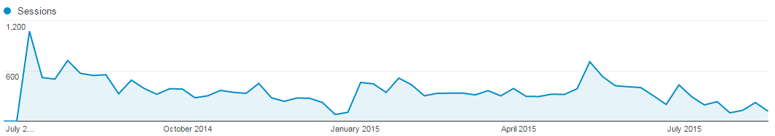

1. The most viewed pages, after the microsite homepage were the localised data tool (13 per cent) – where councils could create their own infographics – the to do list pages (10 per cent) which detailed the policy asks in the ‘100 days’ campaign – and the ‘thoughts on’ page (7 per cent) which included opinion articles from a number of stakeholders.
2. Number of visits to Localised Data page between June 2014 and August 2015.

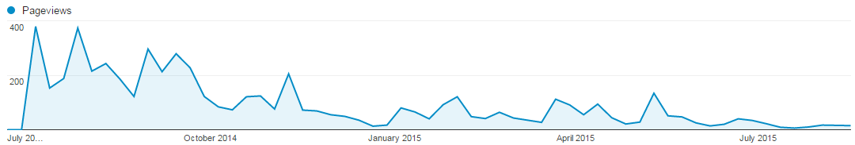

1. Examples of Localised data on the “100 days” website.

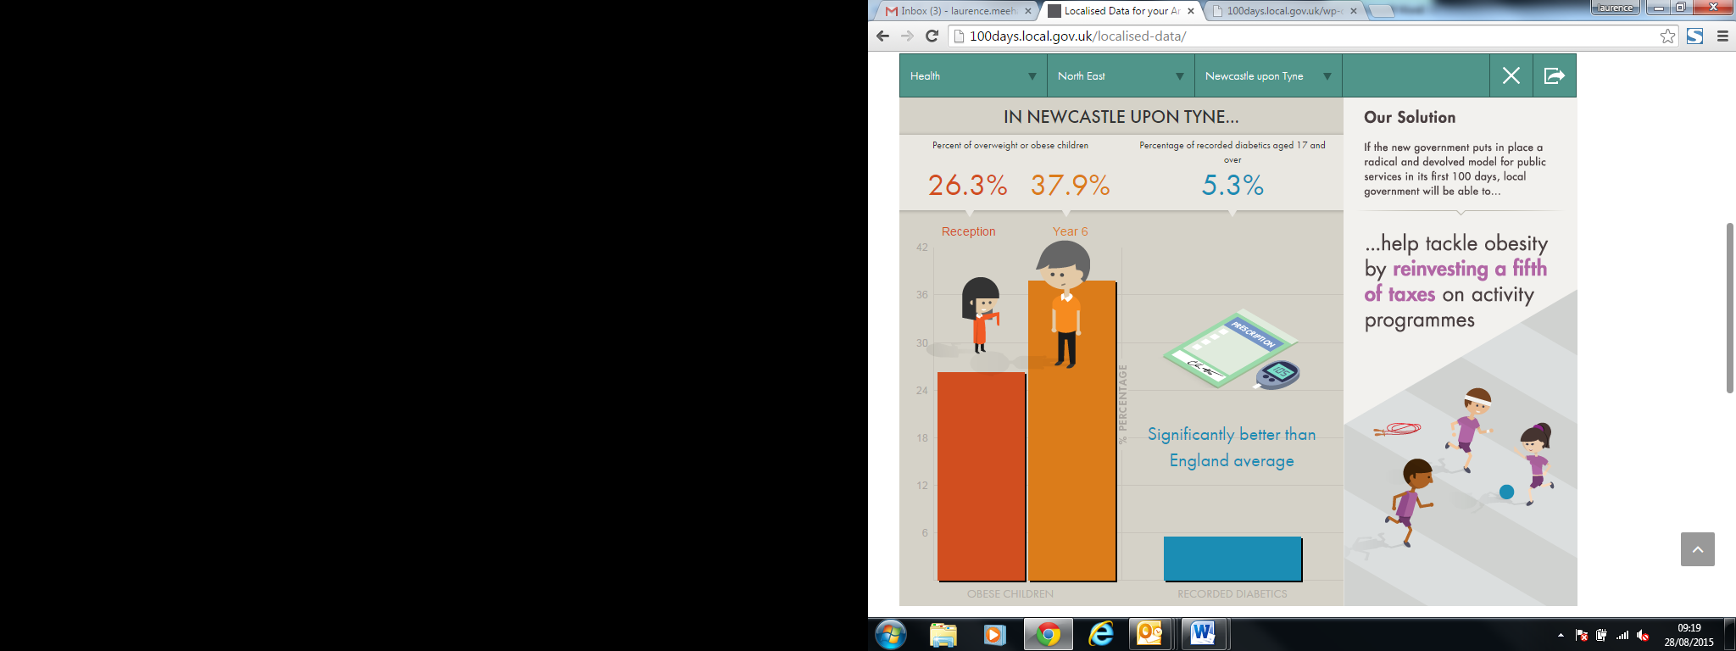 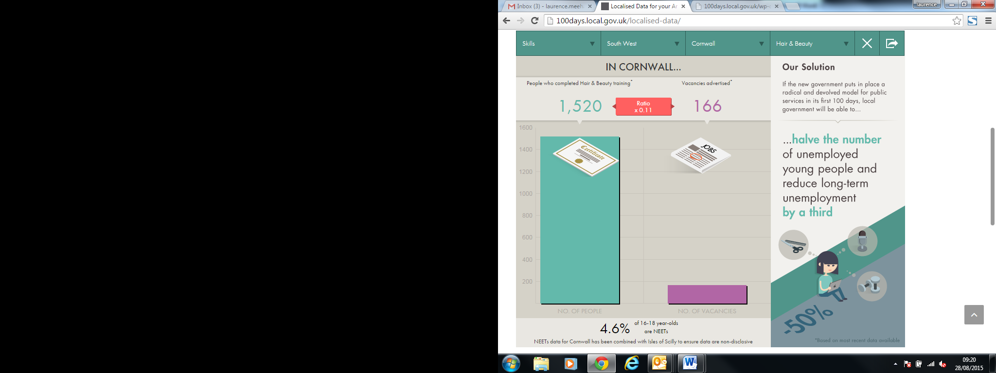

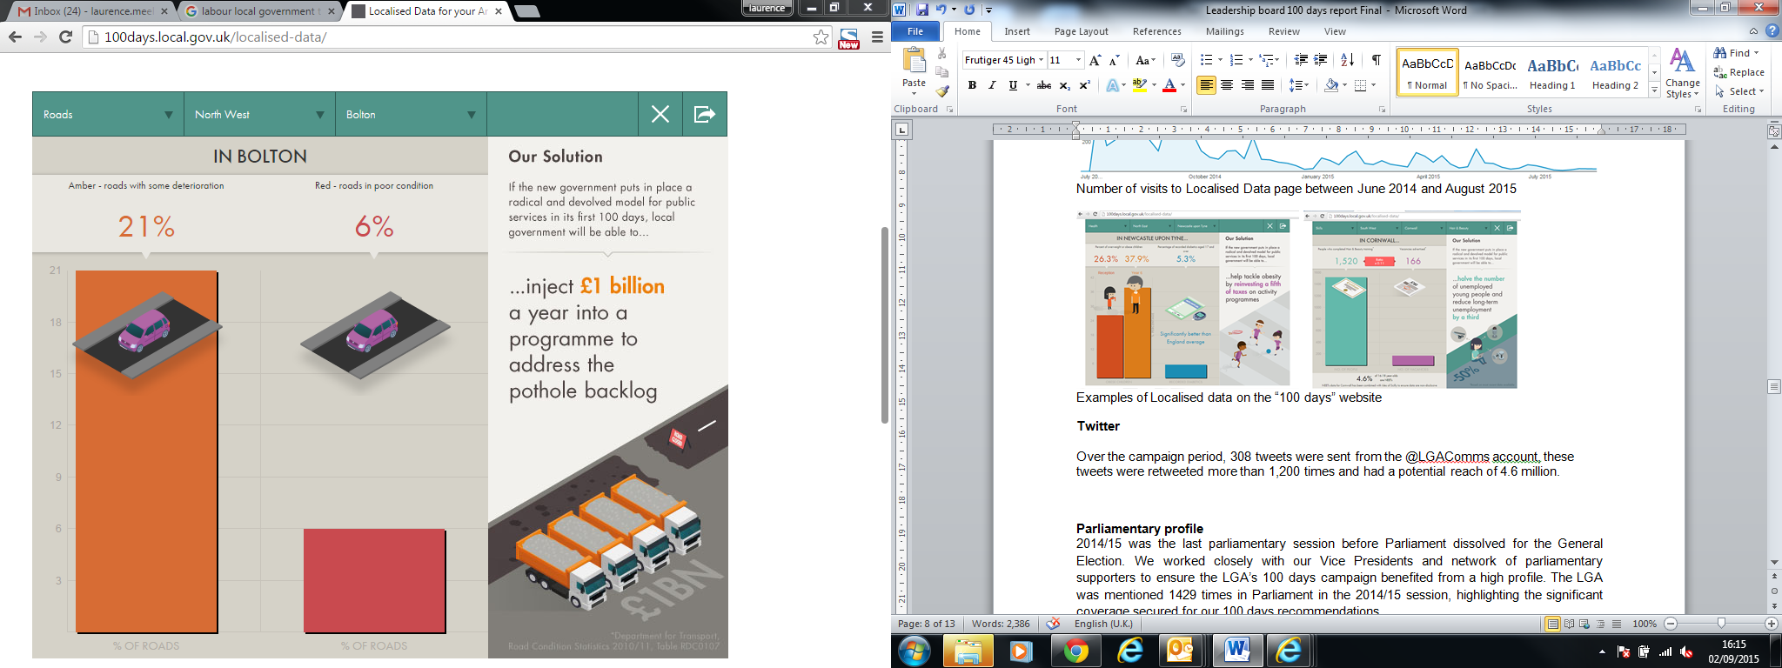 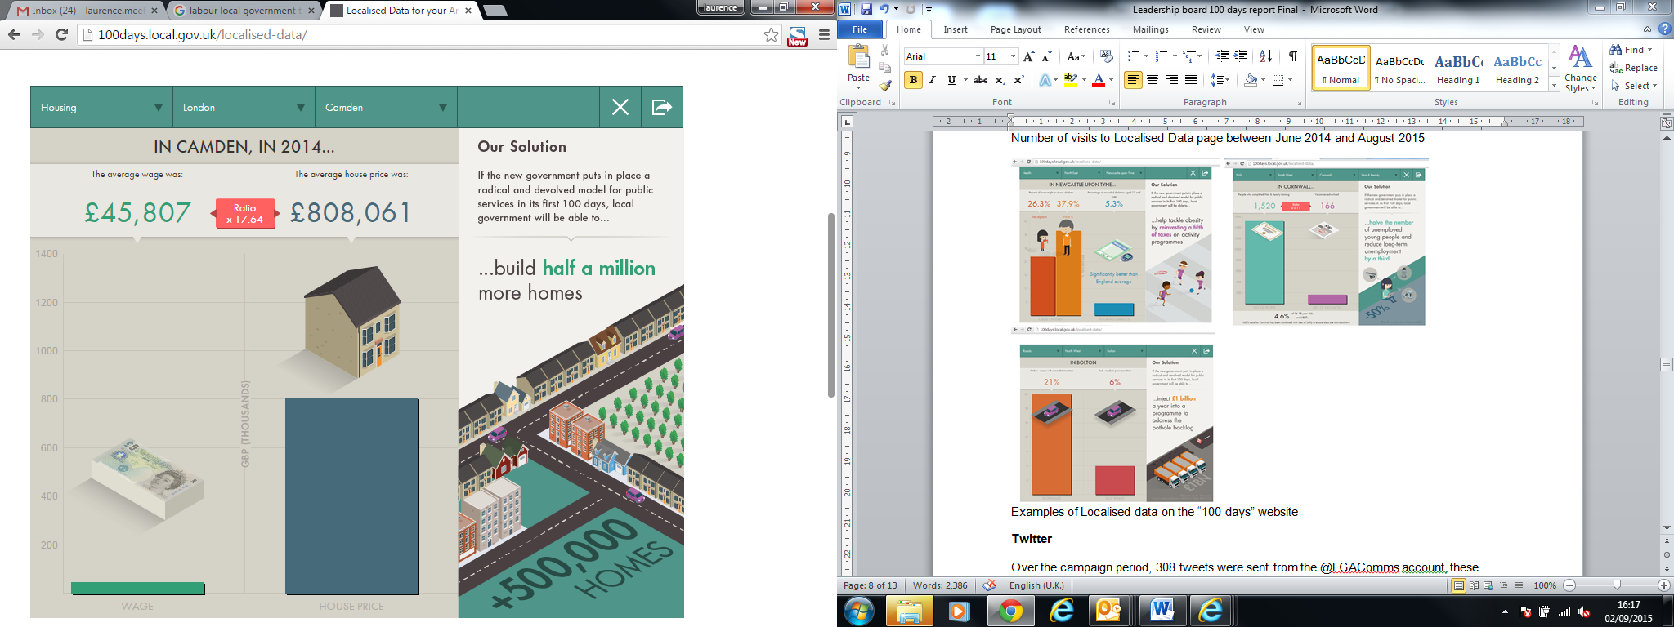

**Twitter**

1. Over the campaign period, 308 tweets were sent from the @LGAComms account, these tweets were retweeted more than 1,200 times and had a potential reach of 4.6 million.

**Media**

1. Since launching our 100 Days campaign at the 2014 LGA Annual Conference, policies and asks were mentioned **315** times across **23** print and online titles and **11** broadcast channels and programmes.
2. Our call for English devolution featured twice on the front page of the **Observer**, our ask for devolution of skills and employment training to local areas was covered on the front page of the **Independent** and 100 Days stories were reported **8** times on **Radio 4’s Today Programme**.

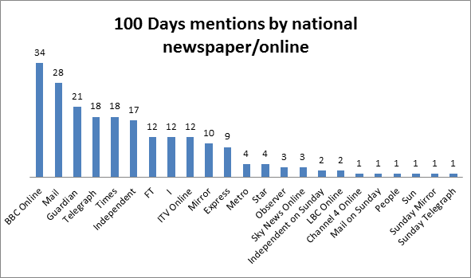

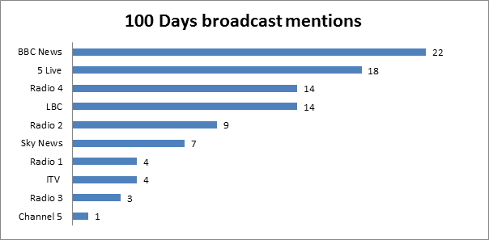

|  |  |
| --- | --- |
| **100 Days story** | **Media hits** |
| School places | 81 |
| Devolution | 51 |
| Fuel duty - potholes | 40 |
| Obesity/Alcohol/Tobacco | 40 |
| Skills | 35 |
| Ofsted review | 18 |
| Housing | 16 |
| Schools accountability | 11 |
| Council tax | 11 |
| Concessionary bus fares | 4 |
| Social workers recruitment | 3 |
| Business rates | 2 |

**‘100 Days’ related headlines**

